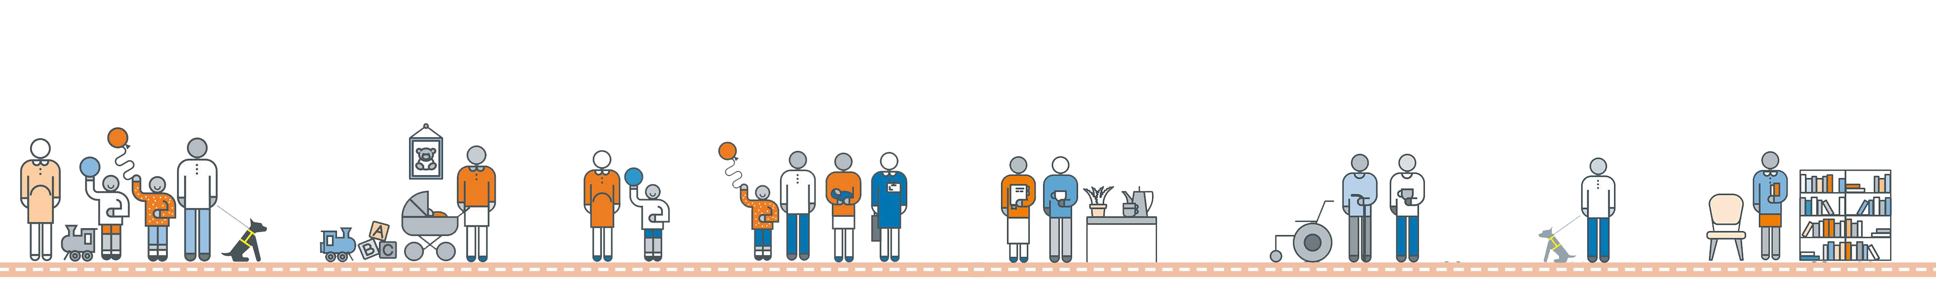

**PARENTS/CARERS DETAILS**

# Parent/carer one

|  |  |  |
| --- | --- | --- |
| First Name: | Surname: |  |
| Date of Birth: | Ethnicity: |
| Is English your first language? | Yes | No |
| First language (if not English): |  |  |
| Are you a refugee/asylum seeker? | Yes | No |
| Do you have a disability? | Yes | No |
| Are you a lone parent? | Yes | No |
| Address (including postcode): |  |  |
| Telephone (home): |  |  |
| Telephone (mobile): |  |  |
| Email:  **Parent/carer two** |  |  |
| First Name: | Surname: |  |
| Date of Birth: | Ethnicity: |  |
| Is English your first language? | Yes | No |
| First language (if not English): |  |  |
| Are you a refugee/asylum seeker? | Yes | No |
| Do you have a disability? | Yes | No |
| Are you a lone parent? | Yes | No |
| Address (including postcode): |  |  |
| Telephone (home): |  |  |
| Telephone (mobile): |  |  |
| Email: |  |  |

**Other carers (childminder/nanny, grandparent, etc.)**

First Name: Surname:

Relationship to child: Telephone:

Email:



**CHILDREN AGED UNDER FIVE IN YOUR FAMILY AND/OR IN YOUR CARE**

# Child one

First Name:

Surname:

Date of Birth:

Sex:

Relationship to you:

Address (if not your own):

Do you have parental responsibility for this child?

# Child two

First Name:

Surname:

Date of Birth:

Sex:

Relationship to you:

Address (if not your own):

Do you have parental responsibility for this child?

# Child three

First Name:

Surname:

Date of Birth:

Sex:

Relationship to you:

Address (if not your own):

Do you have parental responsibility for this child?

# Child four

First Name:

Surname:

Date of Birth:

Sex:

Relationship to you:

Address (if not your own):

Do you have parental responsibility for this child?



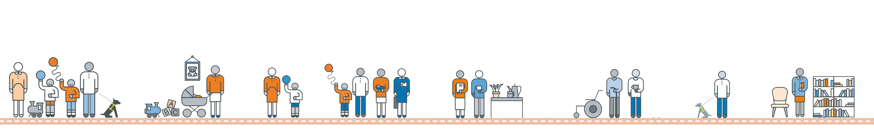

If you are expecting a baby, when is the due date?

**ADDITIONAL INFORMATION**

Employment Status: Employed Volunteering

Are you receiving any benefits? If yes – please specify:

Self-employed Unemployed Maternity Leave Studying/Training

Yes No

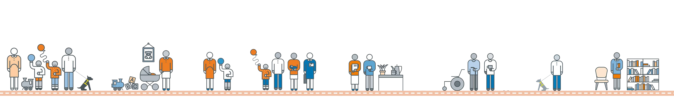

*Consent under Data Protection Act: I understand that the information that is recorded on this card will be stored electronically and used solely for the purpose of providing services to me and my family. Any information regarding me and my family will be kept confidential and will not be passed to organisations outside of Start for Life Services partner agencies without my consent, unless it is of a child protection nature, in which case information will be shared with appropriate agencies. I understand that I can ask to see information held about me and my child(ren) at any time.*