City of London
Threshold Document

Context

The City of London operates a Families in the City model of support for all children, young people and families who live in the City. This involves a Family Help model in line with the Social Care Reform expectations, which provides a wide range of multi-agency support for families to improve family functioning and increase positive outcomes.

Research shows that children benefit most from good quality support at the earliest opportunity. Whilst many children grow up without needing more than the help of universal services. However, some children at various stages of their development and families at different points in their journey, may have additional needs which require tailored plans of support from different agencies so that they can grow up successfully in secure, healthy home environments.

Working Together to Safeguard Children (2023) sets out a clear expectation that local agencies will work together to collaborate to identify children with additional needs and provide support as soon as a problem emerges. Providing help as early as possible is a key element of achieving this and will avoid problems becoming entrenched.

The City and Hackney Safeguarding Children Partnership (CHSCP) has set out a Continuum of Need model which ranges from children who have no additional needs to those whose needs are acute. This continuum is supported by agencies offering a graduated range of support from universal to specialist services.
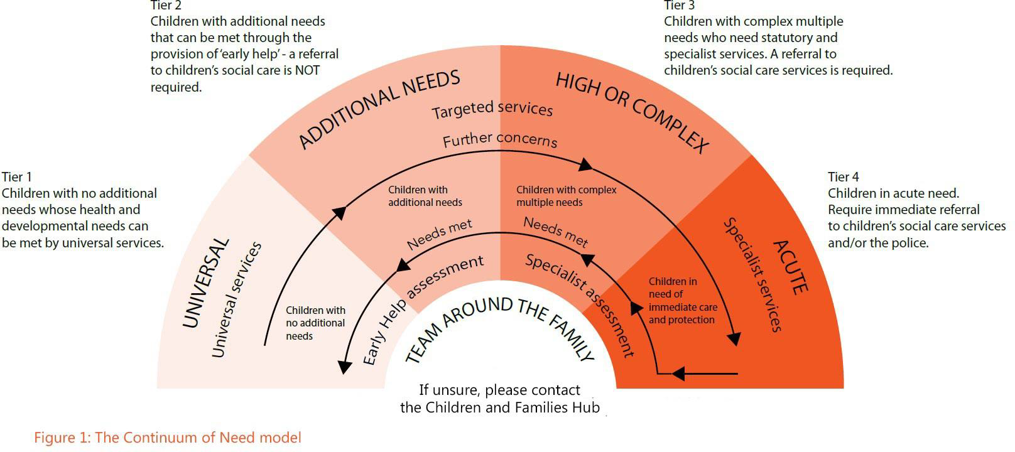

The Family Help model seeks to ensure that when children and families need to move up or down this continuum there is no change to the professionals who are working with them, their lead allocated family practitioner will remain consistent regardless of where they sit in terms of need, with the provision of additional expertise as needed.

Application of Threshold

The City of London works to the Pan London Threshold in terms of identifying and responding to levels of need. The City and Hackney Safeguarding Children Partnership (CHSCP) expects that all practitioners working with children and families know how to identify children who have additional needs or at risk of harm and know how to make a referral for Family Help, using the City of London Multi-Agency Referral Form (see Appendix A).

Level/Tier 1 - Those children whose needs sit at this level will not require a referral for Family Help; however, they can access general advice and signposting about universal services available to them e.g. early years settings, schools, GP’s etc.

Level/Tier 2 – Where it is queried or thought that a child has or could have some emerging or lower-level additional needs that may reduce their opportunity of achieving or maintaining, a reasonable standard of health or development, without additional support. A referral should be made to Family Help via the City of London Multi-Agency Referral Form (see Appendix A).

Level/Tier 3 – Where children and families are experiencing more complex and/or multiple needs which require a targeted and coordinated multi-agency response a referral should be made via the City of London Multi-Agency Referral Form (see Appendix A).

Where children and families who were already open to Level/Tier 2 needs increase and more intensive and structured support needs to be put in place, the same professional network and allocated worker will continue to be in place, with additional resources included and a formal review of arrangements put in place.

Level/Tier 4 – Where it is believed that children have or are likely to suffer significant harm that would have an immediate impact on their wellbeing, or long-term cumulative impact on their health and development outcomes. A referral needs to be made to for Family Help via the City of London Multi-Agency Referral Form (see Appendix A).

Consent

At all referral points family consent should be sought prior to making the referral (Obtaining Consent when Making a Request for Support). If consent is not given single agency support can still be offered from within the multi-agency partnership.

All efforts should be made to explain the service and process in a family friendly and culturally specific way, to support informed decision making by parents or carers.

Only at the point of believing that a child may have, or may be likely to suffer, significant harm would parental consent be overridden and action taken to share information to ensure that children are safe.

Multi-Agency Safeguarding Hub (MASH)

The Multi-Agency Safeguarding Hub (MASH) is a single point of contact which supports to different organisations work together to assess risk and deliver effective and focused services to children and their families. (See Appendix C)
Its core functions are;
- Acting as a single point of entry – gather all notifications related to safeguarding in one place.
- Enabling thorough research of each case to identify potential risk (and therefore the opportunity to address that risk)
- Sharing information between agencies, supported by a joint information sharing protocol
- Triaging referrals, exemplified in the use of agreed risk ratings.
- Facilitating early intervention to prevent the need for more intensive interventions at a later stage.
- Managing cases through co-ordinated interventions.

Thus, bringing together the collective knowledge of core agencies to better understand risk and strengths in families and therefore by provide the right intervention and support at the right time.

Due to the size of the City there is a virtual MASH in operation where all statutory partners and involved service can be contacted and are required to provide information within the 4-24-hour timeframe as specified in ‘MASH Request for Information Form’ (see Appendix C). Information is requested and provided by secure email.

City of London MASH partners include;
- Adult Social Care
- City of London Police
- Early Years (including Early Years settings, Child and Family Centre)
- Education (including Education Welfare, Education Psychology
- Health
- Housing
- Mental Health Services (Adult and Children)
- Probation
- Schools specific to the child(ren)
- Substance Misuse Services (Adults and Children)
- Youth Justice Service
- Other as required

Assessment

In all cases where a referral is made (with appropriate consent) an Assessment will be completed with the family and their network to fully understand their strengths, needs, and wishes for the future.

A multi-agency Plan will then be developed with a central group of professionals identified to help support in progressing the plan and supporting the family to make positive change. Regular Review points will be held and progress monitored.

Family Decision Making Principles

At all stages of need and Family Help involvement the principle of Family Decision Making is at the fore front. Recognising that families are the experts of their own lives and experiences and that wider family and friend networks often contain great strengths, which when utilised effectively can support and maintain positive progress in families.

“Family group decision-making (FGDM) is an umbrella term to describe a voluntary process that allows a family network to come together and make a family-led plan in response to concerns about a child’s safety and wellbeing, collaborating with skilled professionals. These family-led meetings can include identifying practical support for parents, while prioritising the wellbeing of the child.”
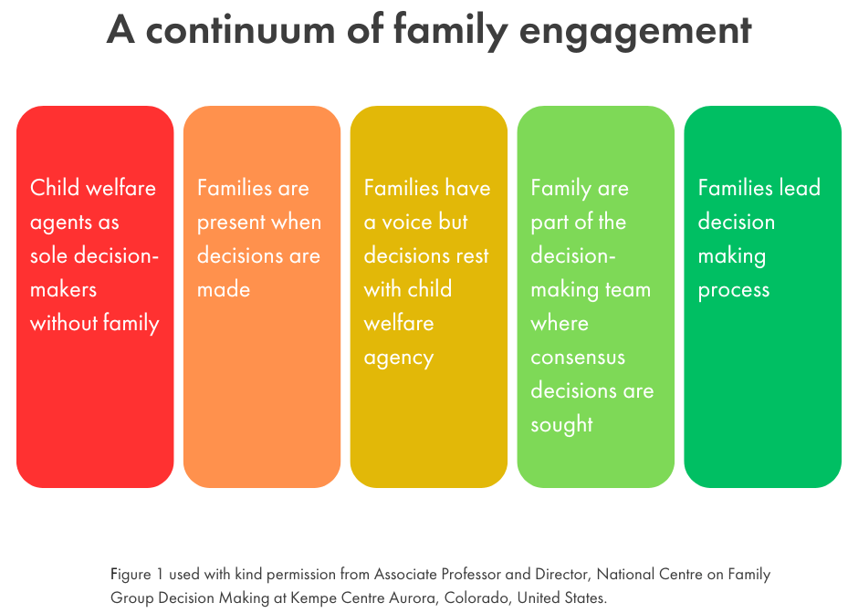
At all Level/Tier of involvement families will be encouraged and supported to bring their wider family, friends and others who provide personal support, together within a family decision making forum to consider what resources and support is available. Devising a plan which the family owns and leads, focusing on the safety and wellbeing of their child(ren), with those that they trust.

It is recognised that this can be a daunting prospect for parents in terms of sharing their personal challenges in an honest and frank way with others, who may not be fully aware of their situation. Family dynamics can be complex and therefore there needs to be a thoughtful, sensitive, and practical approach taken to facilitating these meetings.

An independent coordinator acts as a trusted person, a bridge between the family members themselves and between the family, the Local Authority, and multi-agency partners. Convening a group of family members needs careful preparation to hear the different perspectives and allow all to come to the family group meeting ready to make a plan. Integral to the family decision making process is private family time, when families can meet in private and have open and potentially tough conversations about the way forward in a way that is agreed and owned by all.

At the City of London Family Decision Making is not just at the point of escalation to Court Proceedings or about identifying feasible alternative carers for children. It is about engaging the family and personal network as early as possible to ensure that any challenges do not escalate, and that there is a long-standing network that can be called on for support to keep children safe and families living together.

Children with Disabilities

Children aged under 18 years with disabilities have a right to an Assessment under Section 17 of the Children Act 1989 and a right to receive appropriate support that meets their needs.

A referral to Family Help, as in all other instances, should be made with family consent. A worker will be allocated to complete an Assessment of strengths, needs, and wishes.

Not all children with disabilities require additional support as their needs can be met through universal and specialist, or voluntary services. However, support at any Level/Tier may be applicable to support disabled children to meet their full potential and enjoy safe, social, and full lives.

We have a comprehensive Short Breaks offer at the City which supports children with disabilities access activities and breaks, Local Offer Short Breaks.

Extra-Familial Harm Concerns

Children experiencing harm that occurs outside the home in the community, within organised groups, or from unrelated adults is suffering abuse and should be referred to Family Help, following the same processes as above.

When there is harmful behaviour between peers we would seek to not label children as perpetrators of harm and would want all children involved to be offered a safeguarding response. Extra-Familial Harm thresholds are outlined in the Pan London Threshold.

Once children are referred to Family Help there are various internal pathways to address risk outside the home utilising specialist resources and knowledge including, MACE (see Appendix D), Prevent (Prevent: Our Counter Terrorism Strategy - City of London), and Community MARAC (City Community Multi-Agency Risk Assessment Conference (MARAC) - City of London).

Information Sharing

Good information sharing is vital when professionals are worried about children and want to help them. Early sharing of information is the key to providing effective support at the earliest point where there are emerging problems. At the other end of the continuum, sharing information can be essential to put in place effective child protection services.

Learning from Child Safeguarding Practice Reviews reinforces the fact that both children and adults can suffer significant harm or death when professionals fail to share information or fail to share it in a timely way. Effective communication and appropriate information sharing between professionals is therefore a critical element of effective safeguarding practice.
Whether you are sending an e-mail to another professional, making a phone call or participating in a meeting it is important that your focus remains on the safety and welfare of children and young people and that you share information consistent with the law and statutory guidance.

If you are worried about someone, you are allowed to talk with other professionals without fearing you are doing something wrong. You are not. Talking to each other and sharing information when trying to protect people from harm or to prevent a crime is lawful and in the substantial public interest.

A 10 step guide to sharing information to safeguard children | ICO

DfE non statutory information sharing advice for practitioners providing safeguarding services for children, young people, parents, and carers

Resolving Professional Disputes

At times there may be differences of professional opinion as to the best way to support a child and family, and the level of risk that exists. Different points of view can be healthy and productive for all to review and consider multiple hypothesis and options available. There is not one fundamental right way of viewing complex and multi-layer situations. Professionals need to be respectful of different opinions and seek to resolve these in a child focused and family empathetic approach.

The City of London adopts a Systemic Practice Model considering all aspects of the systems in which families operate, to recognise barriers and internal processes which may be hampering families in making the progress needed.

“When it is our job to help others seek solutions to problems, it can be especially hard to recognise the part professionals can play in creating or maintaining problems.”

There is an agreed CHSCP Dispute Resolution Policy FINAL 2024 across the Partnership, which should be used should differences of opinion not be able to be resolved informally.

Appendix A
July 2025 Multi-Agency Referral Form.docx

Appendix B
July 2025 - MASH Protocol.docx

Appendix C
July 2025 - MASH Information Request Form.docx

Appendix D
Apr 2025 MACE Protocol FINAL.docx

Reform of children's social care in England - House of Commons Library accessed 14/07/2025
Multi Agency Working and Information Sharing Project: Final report, Page 9, accessed 20/01/2025
Children’s Wellbeing and Schools Bill: policy summary notes, accessed 14/07/2025
"Family group decision making - what is it?" - Family Rights Group, accessed 14/07/2025
"Family group decision making - what is it?" - Family Rights Group, accessed 14/07/2025
Information Sharing | chscp, accessed 14/07/2025
What is systemic practice?, accessed 14/07/2025

