The Early Years
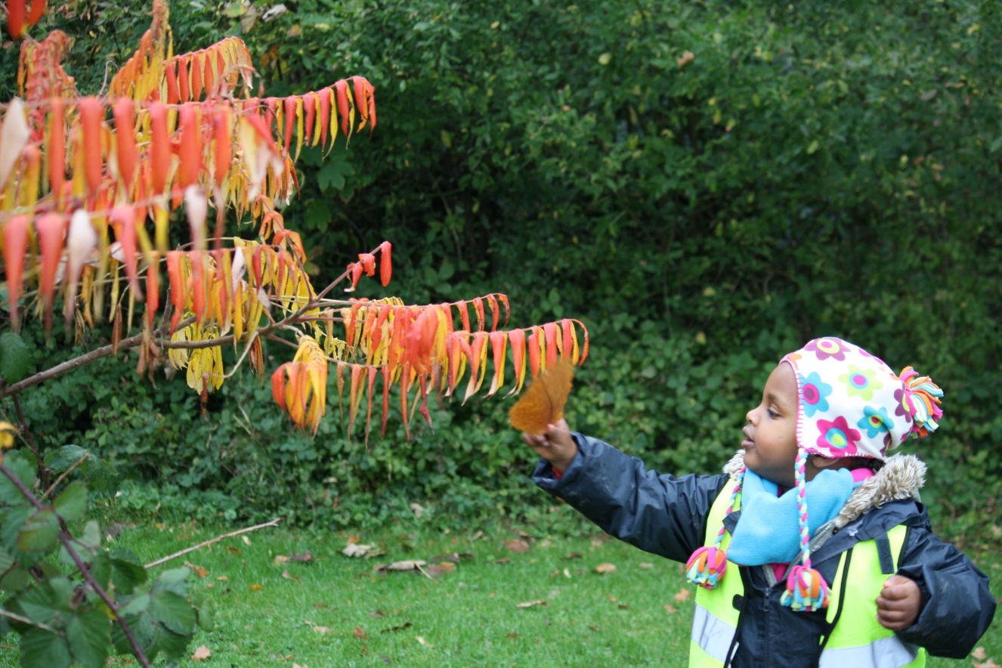
Pete Moorhouse
irresistible-learning.co.uk
Sustainability and Climate Change Audit
This audit is designed to assist you in evaluating your current practice and environment, with a view to looking at what improvements we can be made and how these can best be prioritised through your ‘Sustainability and Climate Change Action Plan’. Some changes be achieved relatively quicky whilst others will be more long term, requiring significant planning and investment. The audit embraces all three pillars of sustainability; social, environmental and economic. There are a wide range of aspects to consider, it can feel daunting, but I hope this audit can help you find goals that are achievable. The most important aspect is to have a clear plan and be actively working towards more sustainable practices, playing our part in creating a brighter future.
Pete Moorhouse

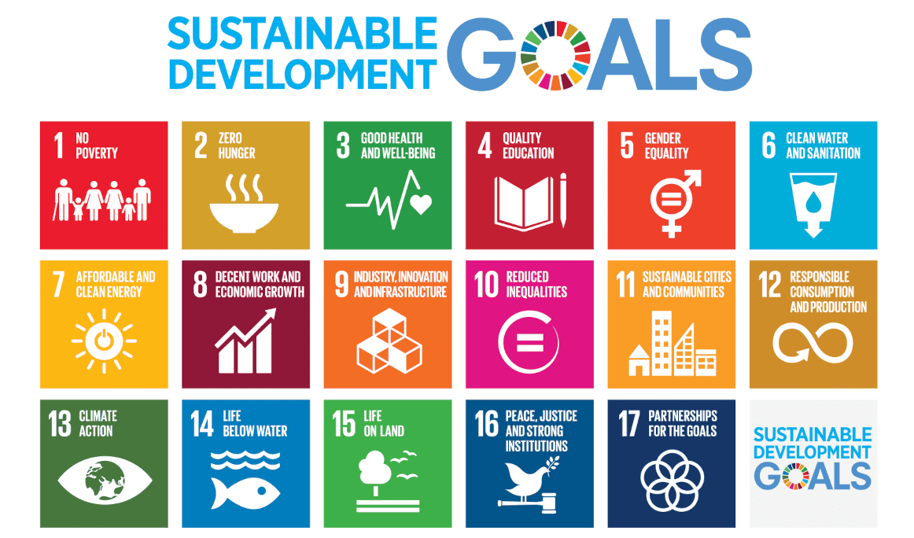
The 2030 Agenda for Sustainable Development, adopted by all United Nations Member States in 2015, provides a shared blueprint for peace and prosperity for people and the planet, now and into the future. At its heart are the 17 Sustainable Development Goals (SDGs), which are an urgent call for action by all countries - developed and developing - in a global partnership. They recognize that ending poverty and other deprivations must go hand-in hand with strategies that improve health and education, reduce inequality, and spur economic growth – all while tackling climate change and working to preserve our environment.

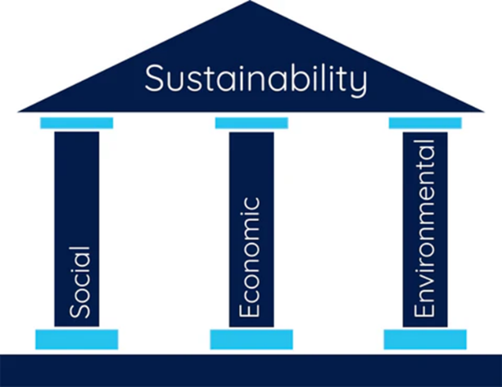

The three pillars of sustainability are based on the Brundtland Report (1987), which was very careful to identify the importance of the key elements of sustainability: environmental regeneration and protection; economic strategies; and equitable societies.
Environmental The pillar focuses on cultivating awareness and appreciation of the natural world, whilst protecting and promoting biodiversity. It incorporates practices that protect the planet - such as recycling and reducing CO2, and encourages the development of environmental responsibility from an early age. This pillar highlights the importance of embedding environmental consciousness within early childhood education.
Social This pillar centres on fostering inclusive environments for children, families, and communities. It focuses on empowering all children to be active participants in their communities and local environments. It prioritises children’s well-being, rights, and holistic development, while promoting social equity and ensuring equal access to opportunities for everyone.
Economic This pillar focuses on building financially viable systems that support long-term sustainability. It aims to ensure early childhood education is affordable and high quality, while maintaining the financial stability of providers, educators, and families. It also highlights the importance of investing in early childhood education, recognising that early investment delivers significant long-term benefits for individuals and society. Economic sustainability is about balancing business with environmental considerations and considering sustainable trade.
Sustainability and Climate Change
Audit
Name: ……………………………….
Setting: ………………………………
Date: ……………….

CONNECTING WITH NATURE | Currently | Aim | Priority level
Is outdoor learning prioritised, at least as much, if not more than indoors
Are children planting and gardening outdoors
Are children involved in all parts of the growing process – from seed to plate
Are there indoor plants
Is forest school practice incorporated
Are children encouraged to slow down and notice the beauty of nature; nature walks, perhaps with cameras, microscopes, magnifying glasses
Do we explore natural elements such as rain, making fires, wind
Do we visit woodlands, parks or beaches
Do we have pets or animals
Do we have opportunity for farm visits
Do children grow plants to take home
Do children monitor the weather
Do we compost
Do we rewild part of our outdoors

BIODIVERSITY | Currently | Aim | Priority level
Do we plant trees, variety of local species and including fruit trees
Are children planting nature gardens with wild flowers
Are we growing vegetables
Do we have bug hotels
Do we have birdboxes
Do we have bat boxes
Do we have
Do we have bird feeders
Do we have wormeries
Can we encourage seed swaps
Do we compost
Do we rewild part of our outdoors
Do we have a (safe) pond area

NOTE: With all these categories – if you think of additional options, please let me know and I can add them and update this audit
studio@petemoorhouse.co.uk

OUTDOOR LEARNING  is general outdoor learning prioritised – with more time outside | Currently | Aim | Priority level
Can children freely access the outdoors
Do we have natural elements in the outdoors, logs, rocks, small ponds
Do we prioritise natural materials outdoors – wooden tables, wooden playhouse etc
Varied outdoor markmaking opportunities, chalk, clay paint, etc
Varied outdoor role play opportunities
Mud kitchen
Sandpit
Water play
Large scale loose parts such as planks, tyres, rope, crates, guttering
Natural loose parts, pebbles, tree rings, etc
Do children garden & compost
Quite areas dens etc
Multi-sensory areas e.g.: sound gardens
Science/ STEM Pulleys, scales
Climbing options
Bikes, trikes and scooters
Lots of seating for adults – to get us down to their level – to better facilitate conversation

MATERIALS | Currently | Aim | Priority level
Do we evaluate both carbon footprint of materials and options for reuse or recycling. Consider source and end of life (final destination).
Do we avoid all food products; threading pasta, tuff trays with lentils, playdough with flour
Do we offer woodwork
Do we offer clay
Do we offer Sewing – threading, stitching, weaving and felting
Use recycled paper
Use recycled card
Use natural found materials for making such a stick men, fairy dens
Natural loose parts indoors and outdoors
Wooden block play indoors and outdoors
Photography, for capturing nature
Explore light, shadows, reflection, projection
Discontinue felt tip pens – use alternatives; pencils, charcoal, chalk
Use natural paints, clay slip, blueberry juice etc
Do we talk with children about where material come form
Use a scrapstore, second hand shops and car boot sales

SUSTAINABLE PRACTICE- EVERY DAY HABITS | Currently | Aim | Priority level
Do we sort waste
Do we recycle
Do we use repurposed items
Do we compost
Are we reducing our consumption/ reducing the amount of waste
Do we turn off lights when not needed
Do we reduce water usage
Do we conserve heating
Mindful of the food we eat – healthy/ local (food miles)/ seasonal/less meat
Promote cloth nappies
Alternatives to wet wipes
Reusable aprons
Equipment switched off, commuters, white boards etc
Travel to setting, by foot/bike pubic transport
Avoid single use plastics and disposable plastics kept to minimum
Less printing
Avoid glitter
Reusable milk bottles

SUSTAINABLE PRACTICE- ENVIRONMENT | Currently | Aim | Priority level
Building design – passive heating
Eco building materials
Solar panels, wind generators
Furnishings; natural flooring, hessian display/documentation boards, more fabric less plastic
Low energy lighting/ timers
Eco friendly furniture
Energy monitors
Water meters
Laundry racks
Washing lines
Limit AI usage (very high carbon footprint)
Adaption and resilience: With hotter temperature/ higher rainfall, stronger winds. Outdoor shade, shelters etc
Rainwater tanks

SOCIAL SUSTAINABILITY | Currently | Aim | Priority level
Do we support families facing distress and hardship
Do we prioritise inclusion
Do we celebrate difference
Do we share out eco- values with families
Do we reach out beyond setting to the local community
Do we welcome parents and volunteers e.g.; to help garden
Do we make our facilities available to the community at the weekend/ evenings (if practical)
Do we nurture staff – well-being and staff development
Do we nurture parents/carers– well-being and development
Could we organise life skills workshops for parents – cooking woodwork, gardening sewing
Could we have home learning bags, with books, resources, recipes etc
Are all culture represented within our setting, picture artworks etc
Liaise positively with other nearby settings, share CPD, liaise with feeder schools
Support local artists – artists in residence
Support local growers
Be a point of networking for the local community

FUTURE SKILLS | Currently | Aim | Priority level
Do we prioritise development in children’s creative and critical thinking
Do we interact to nurture development of creativity - sustained shared thinking
Do we observe progression in children’s creative development - if we value creativity this is essential (See: Holistic Creativity Framework)
Do we offer children numerous opportunities to problem solve for themselves
Do we focus on building key dispositions to learning such as perseverance, resilience and persistence
Do we embed a culture of make and repair
Do we encourage a sense of agency – where children are empowered that they ‘can-do’ (ideas into action)
Encourage an optimistic mindset – avoid talking about climate catastrophe
Embrace stories that relate to the environment, weather, recycling, compost, worms, growing etc
Do we help children develop a love for nature

NOTE: Creative and critical thinking skills have been cited as key skills that children need in order to adapt to a rapidly changing world and to be the future innovators, finding solutions to the increasing challenges we face. For detailed information on how we can best nurture creativity and observe progression see: The Creativity Framework
https://irresistible-learning.co.uk/resource/holistic-creativity-framework/

ECONOMIC SUSTAINABILITY | Currently | Aim | Priority level
Sustainable financial management:
Durable long-lasting materials
Energy efficient lighting and appliances
Reducing paper with digital communication
Repairing toys and furniture
Buying second hand
Support the local economy:
Purchasing food from local farmers
Partnering with local businesses for events
Inviting local artisans or workers to volunteer
Encourage resource efficiency:
Save water and electricity
Compost food waste
Share learning materials between classrooms
Use multipurpose supplies
Invest in staff development:
Sustainable institutions invest in their people
Ongoing teacher training
Fair wages and good working conditions
Low staff turnover (reduces recruitment costs)
Build partnerships and secure diverse funding:
To remain financially stable, settings can:
Apply for educational grants
Collaborate with community organizations
Seek sponsorships for specific programs
Organize fundraising events

MANAGEMENT/ / LEADERSHIP  DEVELOPMENT | Currently | Aim | Priority level
Appointed sustainability lead
Develop a climate action plan (based on audit)
Ensure included in setting improvement plan
Model values - by showing respects for materials and nature and staff, families and community
Develop values and habits in children - via play and everyday experiences - not didactic facts
Access sustainability CPD for all staff
Utilise Local authority initiatives and Early Years advisory team
Access the National Education Nature Park – for further information and resources
https://www.educationnaturepark.org.uk/

Enrol in a program, such as eco schools:
https://www.eco-schools.org.uk/

Visit: Sustainability Support for Education
www.sustainabilitysupportforeducation.org.uk
In depth go-to resource from Liverpool John Moores University
https://www.ncfe.org.uk/media/xbcbjrfj/early-years-sustainability-resource.pdf

Sustainability plans and aims shared on website
Be political: Consider options that best prioritise early years and sustainability
Initiatives to reduce carbon emissions such as Planet Mark and ISO 14001 certification

Implementing a plan
Prioritise aims using the audit, think of realistic time frame. Consider how we can best engage children and families, and how we can measure success.
Sustainability and climate change action plan
Setting: …………………………………….
Short term aims
Short term – 2-8 weeks
Aim:
Expected impact:

Engaging children and families:

Success indicator:

Aim:

Expected impact:

Engaging children and families:

Success indicator:
Aim:

Expected impact:

Engaging children and families:

Success indicator:
Aim:

Expected impact:

Engaging children and families:

Success indicator:

Medium term aims
Medium term 2-12 months
Aim:

Expected impact:

Engaging children and families:

Success indicator:
Aim:

Expected impact:

Engaging children and families:

Success indicator:
Aim:

Expected impact:

Engaging children and families:

Success indicator:
Aim:

Expected impact:

Engaging children and families:

Success indicator:

Long term aims
Long term: up to 5 years
Aim:

Expected impact:

Engaging children and families:

Success indicator:
Aim:

Expected impact:

Engaging children and families:

Success indicator:
Aim:

Expected impact:

Engaging children and families:

Success indicator:
Aim:

Expected impact:

Engaging children and families:

Success indicator:


Another free resource from: Pete Moorhouse - 2016
irresistible-learning.co.uk
This document may be shared, adapted and modified but acknowledge source

