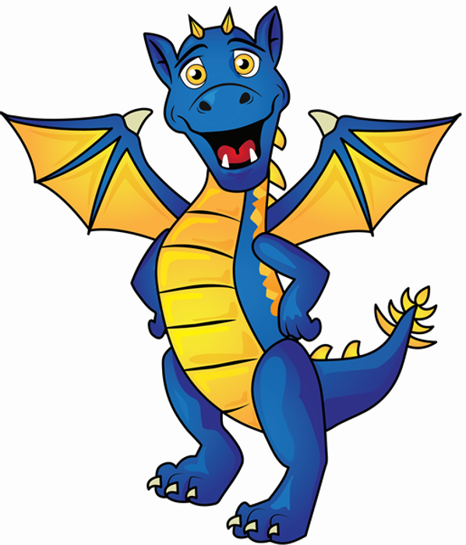
Early Language Development Tracking Sheet
Child’s name:
Key person:
Language(s) spoken at home: DOB:

Term Date | Age (in months) | Term Date | Age (in months) | Term Date | Age (in months)

Age | Listening and attention | Understanding of language | Speaking | Social communication
Birth to 12 months | Listens and responds to familiar voices, sounds, words or finger plays.  Startled by loud noises.  Watches face when someone talks  Quietens or alerts to the sound of speech.  Fleeting Attention – new stimuli takes whole attention. | Respond differently to different tones of voice, especially to familiar people (parents, keyperson) as the tone of voice helps them to understand the meaning.  Is calmed by soft speech or song.  By 12 months, stops and looks when hears own name.  By 12 motnhs, understand frequently used words such as “bye bye”, “no” and “all gone”. | Cries, gurgles, coos to get attention/ express needs.  Vocalises back when talked to, especially to familiar people (copies sounds such as coos, raspberries, and squeals).  Gradually develops speech sounds (babbling)  to communicate with adults.  By 11 months says sounds like ‘baba’, ‘nono’, ‘gogo’.  Uses gestures (waving, pointing) to help communicate. | Gazes at faces and copies facial movements, e.g. sticking out tongue.  Concentrates intently on faces and enjoys interaction and by 12 months uses voice, gestures, eye contact and facial expression to make contact with people and get their attention.  Senses different emotions in parent’s voice and may respond differently, for  example, smile, quieten, laugh  Makes sounds for pleasure (e.g. makes tuneful sounds for minutes at a time to self when lying in a cot or at play.  ‘Takes turns’ in conversation (using babbles)  Laughs during play.
10 to 20 months | Watches and follows adults’ movements.  Responds to music they enjoy by swaying, bouncing, clapping, ...  Enjoys singing or rhyme games.  Concentrates intently on an object or activity of own choosing for short periods but easily distracted by noises or other people and finds it difficult to be directed by an adult.  Using their name helps to focus their attention on what the adult is saying. | Understand some some family names (mummy, daddy, siblings’ names).  Understands and responds to up to 15 simple words in context with a familiar person (e.g. ‘Where’s Mummy?’, ‘Where’s your nose?’ “kiss mummy’ “give it to daddy’).  Understanding of single words in context is  developing, eg ‘cup’, ‘milk’, daddy’. | Plays vocal games, copying noises.  Uses voice and gestures to communicate, attract attention, ask for things, refuse.  By 12 months says words like ‘mummum’ or ‘dada’  Imitates familiar sounds associated with frequently used toys (e.g. baa-baa, moo-moo)  By 15 months, uses approximately 10 single words, even though some might not be clear.  Copies gestures and words from adults.  Uses intonation, pitch and changing volume when ‘talking’. | Likes watching adults for short periods of time.  Watches and listens to others, copying some behaviour in play.  Initiates give and take game by offering objects.  Waves “bye-bye” through imitation and later when asked.  By 18 months, uses pointing with eye gaze to make requests and to share an interest. (by 18 months )  Prefers to play alone, although likes to be near a familiar adult.
18 to 26 months | Listens with interest to general talk.  Plays “ready, steady, go” games, listening and waiting.  Enjoys stories, songs and nursery rhymes and demonstrates listening by  trying to join in with action or vocalisations.  May appear not to hear if  prompts are not provided,  e.g. use of name, ‘stop and listen’ | Understands and follows simple instructions in context e.g. ‘give me’, ‘shoe on’,)  Understand approximately 50 words.  Recognises and points to objects and pictures in books if asked.  Gives named familiar objects to adult,  e.g. coat, car, apple, book | By 24 months, begins to put two words together (e.g. ‘want ball’, ‘more juice’).  Uses different types of everyday words (e.g. banana, go, sleep, hot)  Has favourite phrases.  Sings along with favourite rhymes, using intonation and rhythm.  Begins to ask simple questions.  Uses speech sounds p, b, m, w | Learns to wait for others to finish what they are saying (turn taking).  Talks to self when playing.  Engage in pretend play with toys (e.g. feeding a doll).  Looks to others for responses.  Follows adults’ body language such as pointing, gestures and facial expressions.
24 to 36 months | Listens to and carries out simple instructions.  Recognises and joins in with songs.  Listens with interest to the noises adults make when they read stories.  Can shift to a different task if attention fully obtained  Recognises and responds to many familiar sounds e.g. turning to a knock on the door, looking at or going to the door. | Understand more complex instructions ‘get mummy’s shoes’, ‘put teddy in the box’, ‘get your book, coat and bag’.  Show understanding of prepositions such as “in”, “on”,...  Understand a simple story when supported with pictures.  By 30 months, identifies action words by pointing to the right picture, e.g., "Who's jumping?"  Understands 'who', 'what', 'where' in simple questions (e.g. Who’s that/can? What’s that? Where is.?).  Is developing an understanding of simple concepts (e.g. big/little) | Asks simple questions and talk using speech and facial expressions.  Uses words including descriptive language, time, space, etc.  Begins to make little sentences of up to 4 words.  Tries to repeat many things adult says, either saying the actual word or a close match.  Begins to use word endings (e.g. going, cats)  Uses action, sometimes with talk (e.g. reaches towards toy, saying ‘I have it’).  Uses a variety of questions (e.g., (what, where, who).  Uses simple sentences (e.g. ‘Mummy gonna  work’).  Uses pronouns (me, him, she), plural and prepositions (in, on, under) | Talks aloud when playing with others.  Uses words during activities.  Uses language to make friends, share feelings, experiences and thoughts.  Holds a conversation, but jumps from topic to topic.  Interested in others’ play and will join in.  Enjoys being with and talking to adults and  other children.  Expresses emotions towards adults and peers using words, not just actions.
34 to 50 months | Joins in with repeated refrains and anticipates key phrases in rhymes and stories.  Can concentrate and listen for 10 minutes + in activities they enjoy.  Listen to stories, enjoys looking at books and will request favourite stories.  Listens to others in one to one or small groups, when conversation interests them.  Is able to follow directions (if not intently focused on own choice of activity). | Understands words such as “under”, “behind”, “next to” by carrying out an action or selecting the correct picture.  Understand instructions with two parts e.g. ‘put your coat on and stand by the door’.  Understand ‘why’ questions.  Answers questions more fully, providing more than one piece of information.  Understands use of objects (e.g. "What do we use to cut things?’)  Around 4 years old, is aware of time in relation to past, present and future, e.g. ‘yesterday was rainy but today is sunny’. | Questions why things happen and gives  explanations. Asks e.g. who, what, when, how.  Uses words to give reasons, say what they want, direct others.  Can sing on his/her own.  Can retell a simple past event in the correct order  (e.g. went down slide, hurt finger).  Beginning to use more complex sentences to link thoughts (e.g. using and, because).  Uses a range of tenses (e.g. play, playing, will play, played). | Able to argue with adults and peers if they disagree, uses words not just actions.  Can give information about own life and favourite things.  Beginning to accept the needs of others, with support.  Can initiate conversations.  Forms friendships with other children.  Understands turn taking with adults and peers
4 to 5 years | Attention is now more flexible - the child  can understand spoken instructions related  to a task without stopping the activity to look at the speaker.  Sustains attentive listening, responding to what they have heard with relevant comments, questions or actions.  Sits quietly when appropriate. | Understands instructions containing sequencing words; first…after…last, and more abstract concepts – long, short, tall, hard soft, rough.  Understands humour, e.g. nonsense rhymes, jokes.  Understands rhyme.  Demonstrates understanding of “how?” and “why?” questions by giving explanations.  Able to follow a simple story without pictures or props. | Uses well formed sentences (e.g. ‘I played with Ben at lunchtime’) and is easily understood by adults and peers.  Frequently asks the meaning of unfamiliar words and may use them randomly  Uses language to imagine and recreate roles and experiences in play situations.  Introduces a storyline or narrative into their play.  Attempts to read familiar words in books.  Uses talk to organise, sequence and clarify  thinking, ideas, feelings and events. | Chooses own friends and is generally co-operative with playmates.  Works as part of a group, taking turns  Able to plan construction and make believe play activities (building models from Lego bricks).  Takes turns in longer conversations and uses language to gain information, negotiate, discuss feelings/ideas and give opinions.
Additional notes

